MEENATCHI

ADVANCED

DENTAL CENTER

T.P.T complex, (Near Sun Medical), Ayyampettai,Thanjavur.

**Mobile No: 9994013150**

**Name:**

**Age: Sex:**

**Address:**

**Contact Number:**

**Reffered By:**

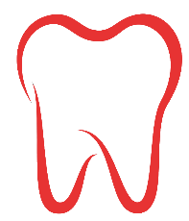

**DR. S. Tamilselvan B.D.S**

**Regd No:- 21820**

Dental Surgeon & certified Implantologist

.

GOD CREATES…. WE RECREATE…

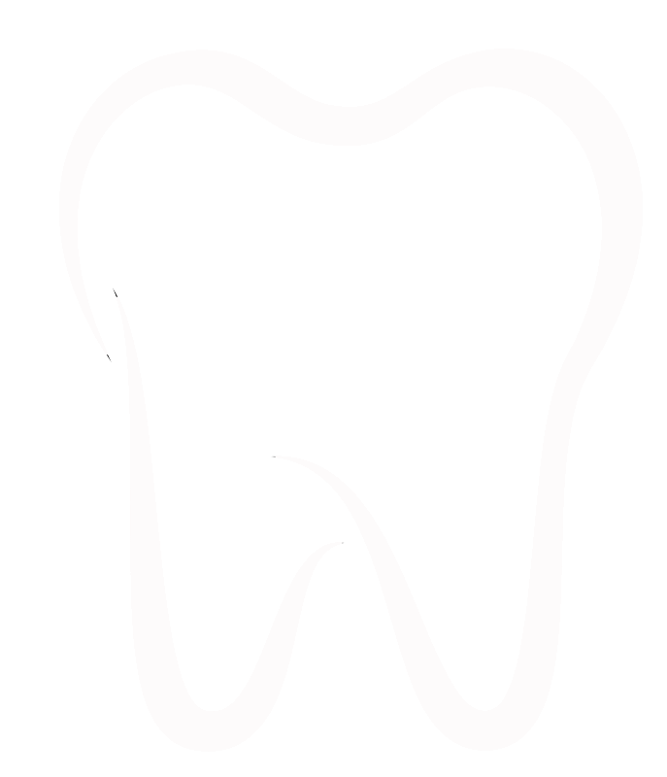



**Date Blood Pressure**

**CLINICAL DIAGNOSIS**

 Stains & Calculus

 Caries Tooth



DC & AP

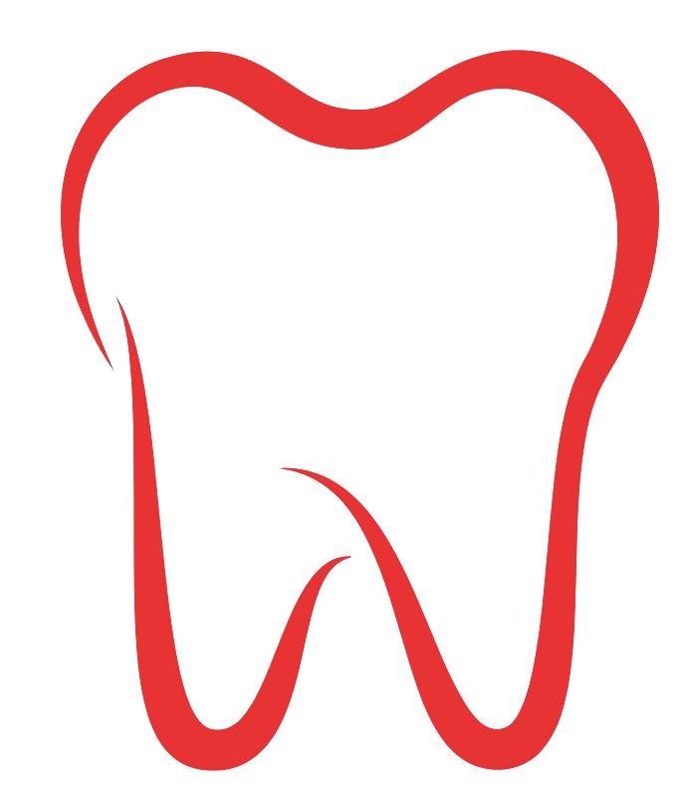



 Missing Tooth



 Root Stemp’s



 Mobile Tooth

 Attrited &



Abrasion Tooth



 Wisdom Tooth

** DIAGNOSIS**

GOD CREATES…. WE RECREATE…



**Treatment plan**

** Treatment Done**

GOD CREATES…. WE RECREATE…



**OUR CLINICS SPECIALIST**

* **DR. INIYAN** MDS

CONSULTANT & PROSTHODONTIST

* **DR. SURESH** MDS

CONSULTANT & ORTHODONTIST

* **DR. MADHU SOODHANAN** MDS

CONSULTANT & ORAL SURGEON

* **DR. RAJKUMAR** MDS

CONSULTANT & ENDODONTIST

* **DR. VIJAY PARTHIBAN** MDS

CONSULTANT & ORAL SURGEON



**WORKING TIME**

**MONDAY to SATURDAY**

Morning : 10.00 am to 2.00pm

Evening : 5.30 pm to 9.00 pm

**SUNDAY**

Morning : 11.00 am to 1.30 pm

GOD CREATES…. WE RECREATE…